Interaction Analysis of Free vs Paid Monetization and Install/Ratings Success Across Countries
- Calculating Conditional Probabilities
  - Country US
    - P(Installs , Free Vs. Paid ∣ Country = US)
      - Threshold = 41,095,550 installs
      - High-install apps (y) = 1495
      - Low-install apps (ȳ) = 13,000 – 1495 = 11,505
Table. Conditional counts of Free/Paid Games and Installs in the US
 | c = Free Games | c̄ = Paid Games | Total
y = installs > 41M | n_{yc} = 1000 | n_{yc̄} = 495 | n_{y} = n_{yc} + n_{yc̄} = 1495
ȳ = installs ≤ 41M | n_{ȳc} = 8750 | n_{ȳc̄} = 2755 | n_{ȳ} = n_{ȳc} + n_{ȳc̄} = 11505
Total | n_{c} = n_{yc} + n_{ȳc} = 9750 | n_{c̄} = n_{yc̄} + n_{ȳc̄} = 3250 | n = n_{y} + n_{ȳ} = 13000
Table. Conditional probabilities of Installs by Free/Paid in the US
 | c = Free Games | c̄ = Paid Games
y = installs > 41M | P_{y ∣ c, US} = 1000/9750 = 0.103 | P_{y ∣ c̄, US} = 495/3250 = 0.152
ȳ = installs ≤ 41M | P_{ȳ ∣ c, US} = 8750/9750 = 0.897 | P_{ȳ ∣ c̄, US} = 2755/3250 = 0.848
$$Odds Ratio Calculation \left(US_{installs}\right): θ =\frac{n_{yc}·n_{ȳ\bar{c}}}{n_{ȳc}·n_{y \bar{c}}} =\frac{1000⋅2755}{495·8750} ≈ 0.64$$
Interpretation (US): In the US, Free apps have 0.64 times higher odds of reaching more than 41 million installs compared to Paid apps.
 | High Installs | Low Intsalls | Averaging
Free | P _{High installs∣ Free} = 0.103 | P _{Low istalls | Free} = 0.897
Paid | P _{High installs∣ Paid} = 0.152 | P _{Low Installs | Paid} = 0.848
 |  |  | 0.335 − 0.210 = 0.125 = 12.5%

    - P(Ratings , Free Vs. Paid ∣ Country = US)
        - Rating threshold = 4.3
        - High-rating apps (y) = 4,700
        - Low-rating apps (ȳ) = 13,000 – 4,700 = 8,300
Table. Conditional counts of Free/Paid Games and Installs in the US
 | c = Free | c̄ = Paid | Total
y = rating ≥ 4.3 | n_{yc} = 3,200 | n_{yc̄} = 1,500 | n_{y} = n_{yc} + n_{yc̄} = 4,700
ȳ = rating < 4.3 | n_{ȳc} = 6,900 | n_{ȳc̄} = 1,400 | n_{ȳ} = n_{ȳc} + n_{ȳc̄} = 8,300
Total | n_{c} = n_{yc} + n_{ȳc} = 10,100 | n_{c̄} = n_{yc̄} + n_{ȳc̄} = 2,900 | n = n_{y} + n_{ȳ} = 13000
Table. Conditional probabilities of Installs by Free/Paid in the US
 | c = Free Games | c̄ = Paid Games
y = rating ≥ 4.3 | P_{y ∣ c, US} = 3200/10100=0.317 | P_{y ∣ c̄, US} = 1500/2900=0.517
ȳ = rating < 4.3 | P_{ȳ ∣ c, US} = 6900/10100=0.683 | P_{ȳ ∣ c̄, US} = 1400/2900=0.483
$$Odds Ratio Calculation \left(US_{ratings}\right): θ =\frac{n_{yc}·n_{ȳ\bar{c}}}{n_{ȳc}·n_{y \bar{c}}} =\frac{3200​⋅6900}{1500·1400} ≈ 0.43$$
In the US, Free games appear to be less successful when success is defined by installs as well as ratings. Free games are much less likely to receive high user ratings as well as high installs.
 | c = High Installs | c̄ = Low Installs
y = rating ≥ 4.3 | P_{y ∣ c} = 3200/10100=0.317 | P_{y ∣ c̄, US} = 1500/2900=0.517
ȳ = rating < 4.3 | P_{ȳ ∣ c, Free} = 6900/10100=0.683 | P_{ȳ ∣ c̄, US} = 1400/2900=0.483

    - Calculating Main Effect:

 | High Installs | High Ratings | Averaging
Free | P _{High installs∣ Free} = 0.103 | P _{High Ratings | Free} = 0.317 | (0.103 + 0.317) / 2 = 0.210
Paid | P _{High installs∣ Paid} = 0.152 | P _{High Ratings | Paid} = 0.517 | (0.152 + 0.517) / 2 = 0.335
 |  |  | 0.335 − 0.210 = 0.125 = 12.5%
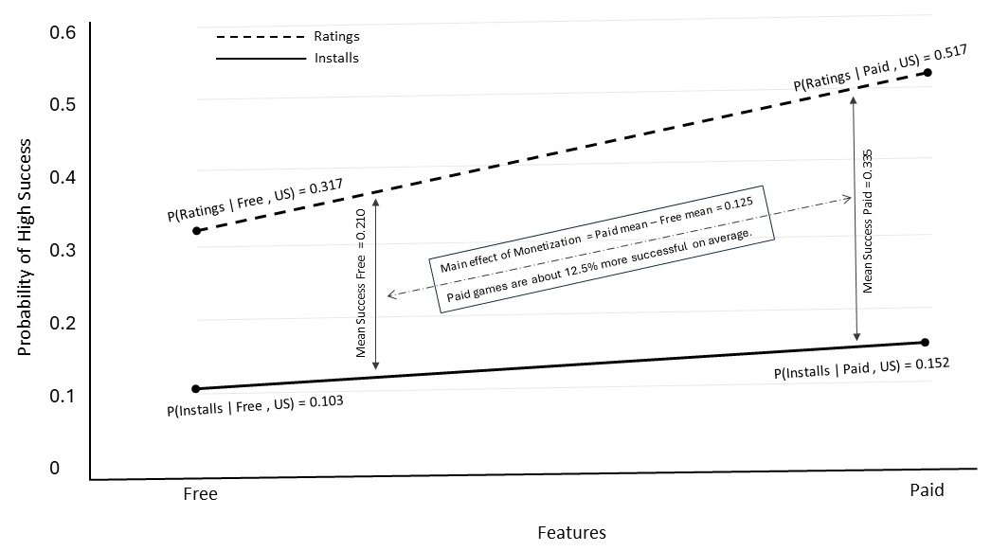
Paid apps are 12.5 % points more successful on average.
Across both success indicators, Paid games consistently outperform Free games in the US market. Paid games show a higher probability of reaching high installs (0.152 vs. 0.103) and an even stronger advantage in achieving high ratings (0.517 vs. 0.317). The odds-ratio analysis reinforces this pattern: the odds of high installs are about 1.5× higher for Paid games (OR = 0.64 when comparing Free to Paid), and the odds of high ratings are more than 2× higher (OR ≈ 0.43 for Free vs. Paid). When success across both outcomes is averaged, the marginal mean success probability is 0.335 for Paid games and 0.210 for Free games, yielding a clear main effect of monetization of 0.125 (≈12.5 percentage-point advantage). Overall, while the install gap is modest, the combined probability, odds-ratio, and main-effect evidence show a consistent and substantially stronger performance advantage for Paid games in US than free games.
  - P(Installs , Free Vs. Paid ∣ Country = India)
    - Threshold (India) = 39,618,510 installs = 39.6M so we can use 40 M
    - High-install apps (y) = 1431
    - Low-install apps (ȳ) = 13,000 − 1431 = 11,569
Table. Conditional counts of Free Games and Installs in the India
 | c = Free Games | c̄ = Paid Games | Total
y = installs > 40M | n_{yc} = 1100 | n_{yc̄} = 331 | n_{y} = 1431
ȳ = installs ≤ 40M | n_{ȳc} = 9300 | n_{ȳc̄} = 2269 | n_{ȳ} = 11,569
Total | n_{c} = 10,400 | n_{c̄} = 2,600 | n = 13000
Table. Conditional probabilities of Installs by Free/Paid in the India
 | c = Free Games | c̄ = Paid Games
y = installs > 40M | 1100/10400=0.106 | 331/2600=0.127
ȳ = installs ≤ 40M | 9300/10400=0.894 | 2269/2600=0.873
$$Odds Ratio Calculation \left(India\right): θ =\frac{n_{yc}·n_{ȳ\bar{c}}}{n_{ȳc}·n_{y \bar{c}}} =\frac{1100·2269}{331·9300} ≈ 0.82$$
Interpretation (UK): Paid apps perform better than Free apps in the UK. Free reduces the odds of reaching >40M installs.
  - P(Installs , Free Vs. Paid ∣ Country = Germany)
    - Threshold (Germany) = 4,066,222,800 installs = 40 M
    - High-install apps (y) = 1521
    - Low-install apps (ȳ) = 13,000 − 1,521 = 11,479

Table. Conditional counts of Free Games and Installs in Germany
 | c | c̄ | Total
y = installs > 40M | 650 | 871 | 1521
ȳ = installs ≤ 40M | 7150 | 4329 | 11479
Total | 7800 | 5200 | 13000
Table. Conditional probabilities of Installs by Free/Paid in Germany
 | c | c̄
y = installs > 40M | 650/7800=0.083 | 871/5200=0.168
ȳ = installs ≤ 40M | 7150/7800=0.917 | 4329/5200=0.833
$$Odds Ratio Calculation \left(Germany\right): θ =\frac{n_{yc}·n_{ȳ\bar{c}}}{n_{ȳc}·n_{y \bar{c}}} =\frac{650⋅4329}{871⋅7150} ≈ 0.45$$
Interpretation (Germany): In Germany, Free apps have about 0.45 times the odds of crossing the high-install threshold compared to Paid apps.
Table. Overall Summary of Results
Country | n_{yc} | n_{yc̄} | n_{ȳc} | n_{ȳc̄} | Odds_{c} (n_{yc} /n_{ȳc}) (Free) | Odds_{c̄}  (n_{yc̄} / n_{ȳc̄}) (Paid) | Odds Ratio θ | Interpretation
United States | 1000 | 495 | 8750 | 2755 | 0.114 | 0.180 | 0.64 | Paid slightly better at very high installs
India | 1100 | 331 | 9300 | 2269 | 0.118 | 0.146 | 0.82 | Paid slightly better
Germany | 650 | 871 | 7150 | 4329 | 0.091 | 0.201 | 0.45 | Paid clearly better
Finland | 520 | 941 | 5480 | 4059 | 0.095 | 0.232 | 0.40 | Strong Paid advantage
Mexico | 980 | 529 | 7520 | 3971 | 0.130 | 0.133 | 0.97 | Free and Paid very similar
Brazil | 910 | 550 | 7550 | 3990 | 0.121 | 0.138 | 0.87 | Slight Free advantage
Pakistan | 1180 | 375 | 8820 | 2625 | 0.134 | 0.143 | 0.79 | Free somewhat better
Indonesia | 1240 | 345 | 8770 | 2645 | 0.141 | 0.130 | 0.86 | Free moderately better
Russia | 620 | 898 | 6880 | 4602 | 0.090 | 0.195 | 0.46 | Paid advantage
Philippines | 1020 | 487 | 7480 | 4013 | 0.136 | 0.121 | 1.09 | Free slightly better

- Calculating Interaction Effect
Now we test the association between Monetization (Free vs Paid) and High Installs across countries by using the ratio of odds-ratios. For each country k, the conditional odds-ratio between y (installs) and c ($Free vs Paid$) is
$$\frac{θ_{\left(yc | r\right)}}{θ_{\left(yc | \bar{r}\right)}}= \frac{\frac{n_{yc r} n_{ȳ\bar{c}r}}{n_{ȳc r} n_{y \bar{c}r}}}{\frac{n_{yc \bar{r}} n_{ȳ\bar{c}\bar{r}}}{n_{ȳc \bar{r}} n_{y \bar{c}\bar{r}}}}$$

Comparing US Vs. FI
$$\frac{θ_{\left(Installs, Free vs Paid | US\right)}}{θ_{\left(Installs, Free vs Paid | FI\right)}} =0.40/0.64≈0.63$$
Because 0.63 ≠ 1, the associations are not homogeneous, so there is interaction on the odds-ratio scale

Comparing US vs. IN
$$\frac{θ_{\left(Installs, Free vs Paid | US\right)}}{θ_{\left(Installs, Free vs Paid | IN\right)}}=0.82/0.64≈1.28$$

Because 1.28 ≠ 1, the associations are not homogeneous, so there is interaction on the odds-ratio scale.

Comparing IN vs. FI

$$\frac{θ_{\left(Installs, Free vs Paid | IN\right)}}{θ_{\left(Installs, Free vs Paid | FI\right)}} =0.40/0.82≈0.49$$

Because 0.49 ≠ 1, the associations are not homogeneous, so there is interaction on the odds-ratio scale.
Results
To examine whether there is an interaction between monetization type (Free vs. Paid) and high-install success across markets, we computed conditional odds ratios θ_(Installs, Free vs. Paid │ Country) for each country and formally tested cross-country homogeneity using the ratio-of-odds-ratios. Pairwise comparisons such as US vs. Finland (≈ 0.63), US vs. India (≈ 1.28), and India vs. Finland (≈ 0-49) deviate substantially from 1, indicating that the conditional odds ratios are not equal across countries. In addition to these magnitude differences, several country pairs, most notably Finland (P(y∣ Paid, FI) > P(y∣ Free, FI)) vs. Philippines (P(y∣ Free, PH) < P(y∣ Paid, PH)), Germany vs. Philippines, and Russia vs. Philippines, exhibit true crossover interactions, where the relative advantage of Free versus Paid reverses direction. This statistically confirms the presence of a three-way interaction between monetization, install performance, and country context. Thus, the success effect of being Free versus Paid is contingent on national market structure rather than reflecting a uniform global relationship.
Results in bit Game & Culture Style
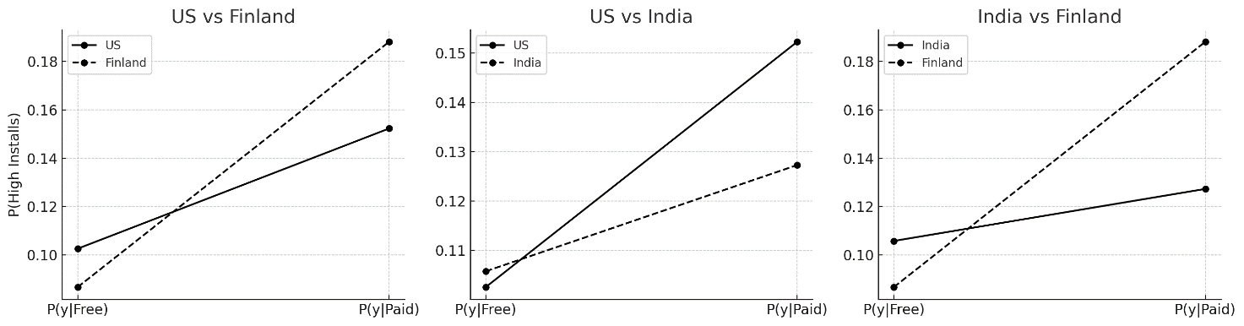
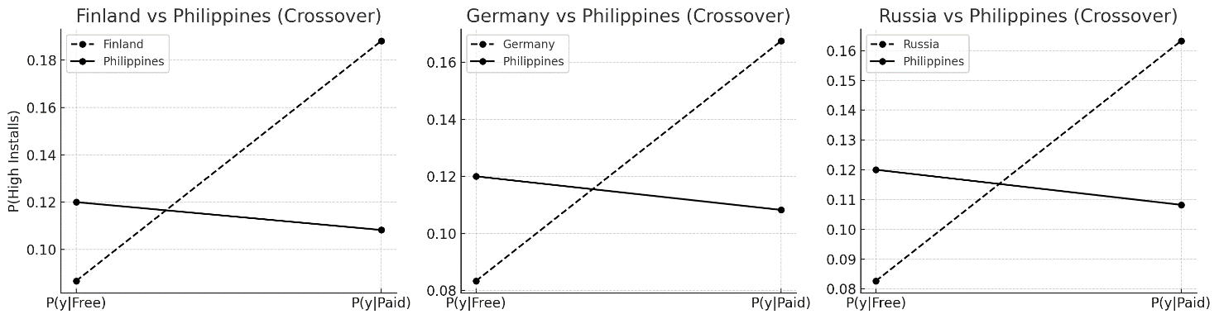
Our findings challenge the common assumption that Free games naturally attract more downloads across all markets. When we examined this relationship statistically, the conditional odds ratios for Free versus Paid games differed sharply across countries, and the ratio-of-odds-ratios showed clear departures from homogeneity. In several markets, Free games did perform better, but in others such as Finland, Germany, and Russia the pattern reversed, with Paid games showing higher probabilities of reaching the high-install category. In a few cases, these differences even produced crossover effects, where the relative ordering of Free and Paid success flips across countries, underscoring the instability of any single global pattern. These results point to a meaningful statistical interaction: the effect of monetization on install performance changes depending on the cultural and economic context in which players encounter a game. Rather than a universal rule, the perceived advantage of Free-to-play emerges as a context-specific outcome shaped by local expectations, purchasing norms, and market structures.

